Accessibility
Accessibility means that the online service is designed to be used by everyone. Accessibility refers to non-hindered access to the online world. Accessibility means that as many different people as possible are able to easily use the online service.
An accessible online service is technically flawless, it has a clear user interface and its content is understandable.
Mediamaisteri Oy ensures accessibility with the following measures:
- Accessibility is part of our operating approach.
- Accessibility is included in our internal practices.
- We constantly offer our personnel accessibility training.
- Our organisation has clear objectives and levels of responsibility concerning accessibility
- We constantly develop the accessibility of our learning environment

Web Accessibility Directive
This website is subject to the Digital Services Act, which states that public online services must be accessible. This means that the online service must been levels A and AA of the requirements set out in the Web Content Accessibility Guidelines (WCAG) 2.1 criteria.
The Web Accessibility Directive, which entered into force in 2019, regulates that the websites and mobile services of the public sector must be accessible. The Act also applies to public companies operating in the water and energy management as well as traffic and postal services’ sectors, and operators in the financial sector. The Act will also apply to organisations that receive more than half of their funding from public entities.
The application of the accessibility requirements was initiated in stages and conformity is supervised in Finland by the Regional State Administrative Agency of Southern Finland. The legal requirements and relevant guidelines shall be published on the saavutettavuusvaatimukset.fi website.

Accessibility of the website
The Pinja online learning environment is based on the open source Moodle platform. The Pinja learning environment aims to meet levels A-AA of the WCAG 2.1 criteria.
The website partially meets the requirements, and it has the following shortcomings:
- 1.4.5 Images of Text - level AA
  - Some of the images lack a text description (so-called ALT attribute)
- 3.3.2 Labels or Instructions – level A
  - some input fields are missing a title (so-called label data)
- 2.4.1 Bypass Blocks – level A
  - navigation: order and nesting of h1, h2, h3 and h4 elements should be improved in order to facilitate navigation

Assessment methods
Mediamaisteri Oy has assessed the accessibility of this website as a self-assessment carried out in cooperation with the company or organisation.

Technical implementation
The Pinja online learning environment is based on the open source Moodle platform. Moodle is designed to offer all people with similar functionalities and the same data. This means that despite the people’s limitations, assistive software, monitor sizes or various terminal devices (e.g. mouse, keyboard or touchscreen), there should be no limitation to the use of the online service.
The website has been designed to be compatible with the following browsers:
- Edge
- Firefox
- Chrome
The accessibility of the website depends on the functionality of the following technologies:
- HTML
- CSS
- Javascript

Feedback and contact details
Did you observe an accessibility-related shortcoming on the website? Please let us know and we will do our best to rectify the shortcoming. You can contact us in the following ways:
- Phone: 0981657890
- Email: arbis@ esbo.fi
- Postal address: PB 3560, 02070 Esbo stad
We aim to respond to feedback within 14 business days.

Supervising authority
If you observe any accessibility issues on the website, please provide us with feedback first. If you are not satisfied with the response you receive, you can provide feedback to the Regional State Administrative Agency of Southern Finland. You can find more details on how to lodge an appeal and how the issue in processed by visiting the Regional State Administrative Agency of Southern Finland’s website.

Supervising authority’s contact details
Regional State Administrative Agency of Southern Finland
Accessibility Supervision Unit
www.saavutettavuusvaatimukset.fi
saavutettavuus(at)avi.fi
phone number switch 0295 016 000

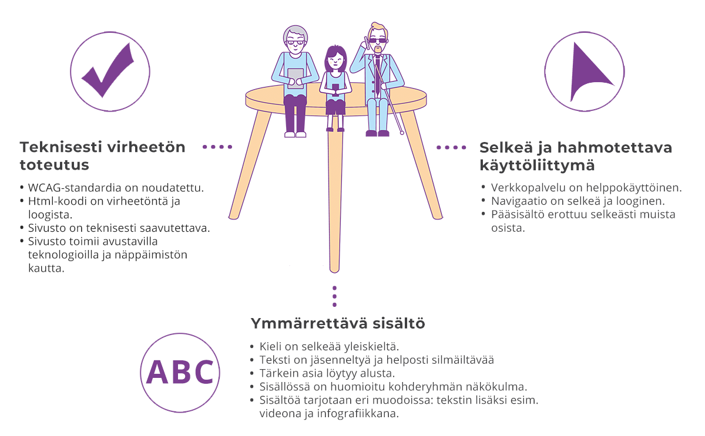
Source: https://www.saavutettavuusvaatimukset.fi/saavutettavuus/

